Early Life
Robert Fulgham Adell Jr. was born in Los Amates, Guatemala, on the 19th of February, 1923. His mother Mabel Fulgham and his father Robert William Adell were missionaries at the Friends mission in Guatemala. Adell’s family returned to the United States in November of 1924, when Adell was one. In 1926, Adell’s sister Helen was born in California. The Adell family continued to do missionary work in Central America throughout Adell’s childhood, returning to the United States once again in 1932. As a teenager, Adell lived with his family in Los Angeles. While in high school, he worked as a newsboy.
WSC Experience
Robert attended Washington State College in April and May of 1943, as a pre-flight student of the Army Training program. He stayed in R.C McCroskey Hall with other army students. Before coming to WSC, he completed preliminary training in Fresno, California. When his class of Air Corps arrived on campus, the students embraced them as their own and invited them to various events. According to an article in the Evergreen, the WSC student newspaper, “weekend memories rationed out by the ‘College Gang’ are appreciated and much looked forward to.” Adell attended at least one party thrown by the college students and was seen dancing with other students. An Evergreen article published after his death stated that his parents told the coordinator of the war training program that his time in Pullman had meant a lot to Adell.
Military Service
After leaving Washington State College, Adell continued to train. He was sent for more training in Santa Ana, California, “with a brilliant squadron which established a scholastic record at that base that still stands.” While at primary training in Hezmet, California, Adell was involved in an accident. He spent six weeks in the hospital and then was sent to complete his training in Douglas, Arizona.
On May 8, 1944, Adell was aboard a plane when it crashed, just seven miles southeast of Tombstone, Arizona. Another passenger was also killed, commanding officer Charles O. Armstrong. It was only fifteen days before his scheduled graduation.

Postwar Legacy
After he passed, the Army sent his parents, Mabel and Robert Sr., his wings and commission as a lieutenant. Adell earned the American Campaign Medal and the World War II Victory Medal. He is buried in Rose Hills Memorial Park, in Los Angeles, California.

Pictures (1 total):
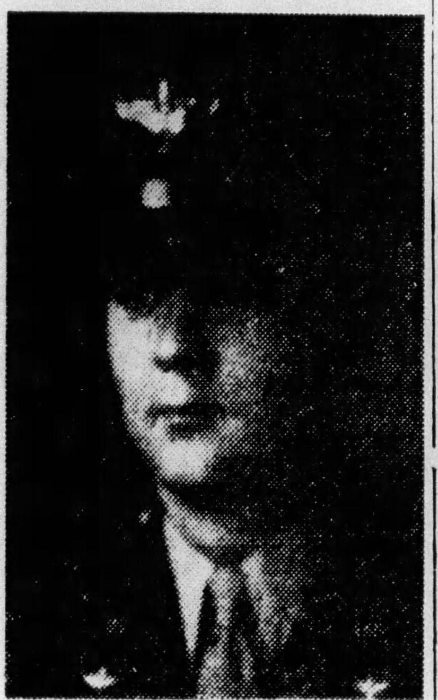
Citation: Robert Fulghum Adell, Find a Grave, https://www.findagrave.com/memorial/110458218/robert-fulghum-adell?_gl=1*1egmtnt*_gcl_aw*R0NMLjE3NDc2OTMzNjcuQ2p3S0NBandyYXZCQmhCakVpd0FJcjMwVkZFV19ZMUNUMmhfaGM5R1VrR3NIWWlLTjJZWl8xZ1V1R0I4VGpSdC1UYy1RQ0lxNkhmd1JSb0NmemtRQXZEX0J3RQ..*_gcl_dc*R0NMLjE3NDc2OTMzNjcuQ2p3S0NBandyYXZCQmhCakVpd0FJcjMwVkZFV19ZMUNUMmhfaGM5R1VrR3NIWWlLTjJZWl8xZ1V1R0I4VGpSdC1UYy1RQ0lxNkhmd1JSb0NmemtRQXZEX0J3RQ..*_gcl_au*MTkwNjgzNzg1OS4xNzQ3Njg2NzQ5*_ga*MTk0NTA0NjU3NS4xNzQ3Njg2NzU1*_ga_4QT8FMEX30*czY4OTllYzJjLTEzOGYtNGNhOS04Mjg3LThlMzI3ZWNiYWE2NSRvOCRnMSR0MTc0ODI5NDA1NCRqNTUkbDAkaDAkZE5nRTZzc0JnZE5qYWtvenY0MmtGOGkzNmtWODlzV3E2THc.*_ga_LMK6K2LSJH*czY4OTllYzJjLTEzOGYtNGNhOS04Mjg3LThlMzI3ZWNiYWE2NSRvOCRnMSR0MTc0ODI5NDA0NCRqMCRsMCRoMA.., (accessed May 2025).

Robert Fulgen Adell in Guatemala, Civil Registration, 1877-1980, Ancestry.com. Guatemala, Civil Registration, 1877-1980 [database on-line]. Lehi, UT, USA: Ancestry.com Operations, Inc., 2014, https://www.ancestry.com/search/collections/9884/records/2275977 (accessed May 2025).
“Killed in Plane Crash-”, The Whittier News, May 9, 1944, pg. 4 https://www.ancestry.com/search/collections/61843/records/902513952 (accessed May 2025).
Robert Adell, The National Archives At Washington, D.C.; Washington, D.C.; Passenger Lists of Vessels Arriving At New Orleans, Louisiana, 1903-1945; NAI Number: 4492741; Record Group Title: Records of the Immigration and Naturalization Service; Record Group Number: 85, (accessed May 2025).
Robert F. Adell, The National Archives at Washington, D.C.; Washington, D.C.; Passenger Lists of Vessels Arriving At San Pedro/Wilmington/Los Angeles, California; NAI Number: 4486355; Record Group Title: Records of the Immigration and Naturalization Service, 1787-2004; Record Group Number: 85 (accessed May 2025).
Helen R. Adell, United States of America, Bureau of the Census. Sixteenth Census of the United States, 1940. Washington, D.C.: National Archives and Records Administration, 1940. T627, 4,643 rolls.
Robert F Adell, United States of America, Bureau of the Census. Sixteenth Census of the United States, 1940. Washington, D.C.: National Archives and Records Administration, 1940. T627, 4,643 rolls (accessed May 2025).
Robert F Adell, Honor States, https://www.honorstates.org/profiles/372199/ (accessed in June 2025).
Robert Fulghum Adell, Find a Grave, https://www.findagrave.com/memorial/110458218/robert-fulghum-adell?_gl=1*1egmtnt*_gcl_aw*R0NMLjE3NDc2OTMzNjcuQ2p3S0NBandyYXZCQmhCakVpd0FJcjMwVkZFV19ZMUNUMmhfaGM5R1VrR3NIWWlLTjJZWl8xZ1V1R0I4VGpSdC1UYy1RQ0lxNkhmd1JSb0NmemtRQXZEX0J3RQ..*_gcl_dc*R0NMLjE3NDc2OTMzNjcuQ2p3S0NBandyYXZCQmhCakVpd0FJcjMwVkZFV19ZMUNUMmhfaGM5R1VrR3NIWWlLTjJZWl8xZ1V1R0I4VGpSdC1UYy1RQ0lxNkhmd1JSb0NmemtRQXZEX0J3RQ..*_gcl_au*MTkwNjgzNzg1OS4xNzQ3Njg2NzQ5*_ga*MTk0NTA0NjU3NS4xNzQ3Njg2NzU1*_ga_4QT8FMEX30*czY4OTllYzJjLTEzOGYtNGNhOS04Mjg3LThlMzI3ZWNiYWE2NSRvOCRnMSR0MTc0ODI5NDA1NCRqNTUkbDAkaDAkZE5nRTZzc0JnZE5qYWtvenY0MmtGOGkzNmtWODlzV3E2THc.*_ga_LMK6K2LSJH*czY4OTllYzJjLTEzOGYtNGNhOS04Mjg3LThlMzI3ZWNiYWE2NSRvOCRnMSR0MTc0ODI5NDA0NCRqMCRsMCRoMA.., (accessed May 2025).
Letter to The State College of Washington from Mrs. Mabel F Adell, June 29, 1944, Washington State University Manuscripts, Archives, and Special Collections, War Records, 13.
“Fireside Thanks,” Washington State Evergreen, April 27, 1943, 4. https://content.libraries.wsu.edu/digital/collection/evergreens/id/16219/rec/1 (accessed June 2025).
“Casualties Coming At Faster Speed,”
“Casualties Coming At Faster Speed,” Washington State Evergreen, July 11, 1944, https://content.libraries.wsu.edu/digital/collection/evergreens/id/102016/rec/4 (accessed May 2025).
“Casualties Coming At Faster Speed,”
“Casualties Coming At Faster Speed,”
“Pasadenan Killed in Training Plane Crash in Arizona,” Los Angeles Times, May 9, 1944, https://www.ancestry.com/search/collections/50029/records/4726791440 (accessed June 2025).
“Casualties Coming At Faster Speed,”
“Casualties Coming At Faster Speed,”

