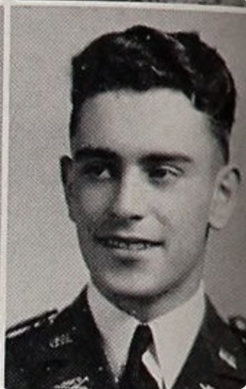
Early Life
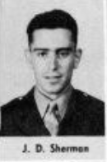
John Dewey Sherman was born in Minneapolis, Minnesota on August 12th, 1924, to Howard and Gladys Sherman. The Sherman family soon moved to Butte, Montana, where Howard got a job as a sampler in a copper mine. In 1930, John’s sister Patricia was born. When John was a teenager, the Shermans moved to Boise City, Idaho. His father continued to work in the mining industry, becoming a civil engineer. John graduated from Boise High School, where he was an active member of Pep Band, Concert Band, the Science Club, and the Scarlet Shirts. He was also the Treasurer of the Boys’ Federation, a social club for boys that put together events at school. During his freshman and sophomore years, he was also involved in ROTC and Rifle Team. He graduated in 1942.
WSC Experience
John attended WSC from 1942-1943. He studied chemistry and had high grades before enlisting in the Air Force.
Military Service
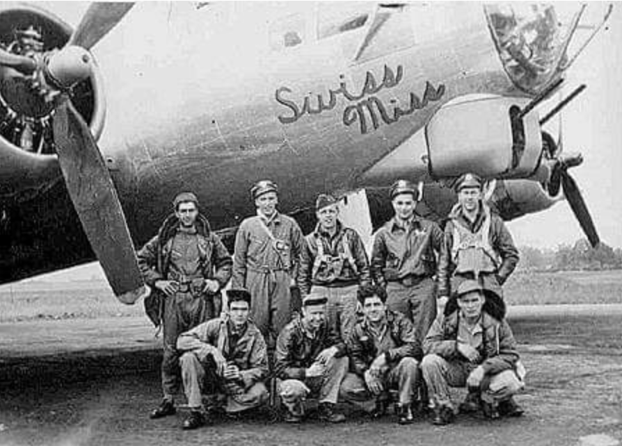
John enlisted in the US Army Air Force and was assigned to the 545th Bombardment Squadron and the 384th Bomb Group, on June 8, 1944. He trained as a Radio Operator and Gunner and was promoted to Technical Sergeant on July 1, 1944. He served as a radio operator on a b-17 Flying Fortress nicknamed the “Swiss Miss.” Due to poor weather conditions while flying over Cambridge, England, the aircraft collided with another plane from the squadron. Out of eighteen crew members on both aircrafts, fourteen, including John, were killed. This incident occurred on July 7, 1944, just one week after John’s promotion to Technical Sergeant.
Burial, Recognition, and Legacy
John is buried at the Cambridge American Cemetery, in Cambridge, England. He was awarded a Purple Heart and an Air Medal for his sacrifice. He is not memorialized on the WSU Veteran Memorial Plaque.

U.S Census Bureau, Fifteenth Census of the United States, Population Schedule, https://www.ancestry.com/discoveryui-content/view/106413711:6224 (accessed July 2022).
U.S Census Bureau, Fifteenth Census
Boise High School, Courier, (Boise, Idaho, 1942), 52, Classmates.com, https://www.ancestry.com/discoveryui-content/view/360720574:1265?_phsrc=CLX41&_phstart=successSource&gsfn=john+dewey&gsln=sherman&ml_rpos=1&queryId=1e14b23d202e03a33857a5c951cc812c, (accessed July 2022).
“SGT. J SHERMAN DIES IN ACTION,” The Spokesman Review, July 26, 1944, https://www.newspapers.com/image/569342730/?article=b68983a6-b952-47b8-912e-352b7762513b&focus=0.26059875,0.76376516,0.38086626,0.8933279&xid=3355&_gl=1*quekpi*_ga*ODA4OTQxMzY2LjE2NTI5Nzg4NDc.*_ga_4QT8FMEX30*MTY1NzY1ODk1MS4xNy4xLjE2NTc2NjAxMTYuMA..&_ga=2.25297977.542725647.1657658952-808941366.1652978847, (accessed June 2022)
Sherman, John Dewey, 384th Bombardment Group, https://384thbombgroup.com/_content/_pages/person.php?PersonKey=3648, (accessed July 2022).
“42-102442 | American Air Museum in Britain.” n.d. https://www.americanairmuseum.com/aircraft/1493, (accessed June 2022).
War Department, US Army Air Force, “Report of Aircraft Incident.” War Department A.A.F Form No. 14, July 1944, https://384thbombgroup.com/_content/ACCIREP/AR44-07-07-515.pdf (accessed June 2022).
In Memory of John D. Sherman, American Battle Monuments Commission, https://www.abmc.gov/print/certificate/509974, (accessed August 2022).

