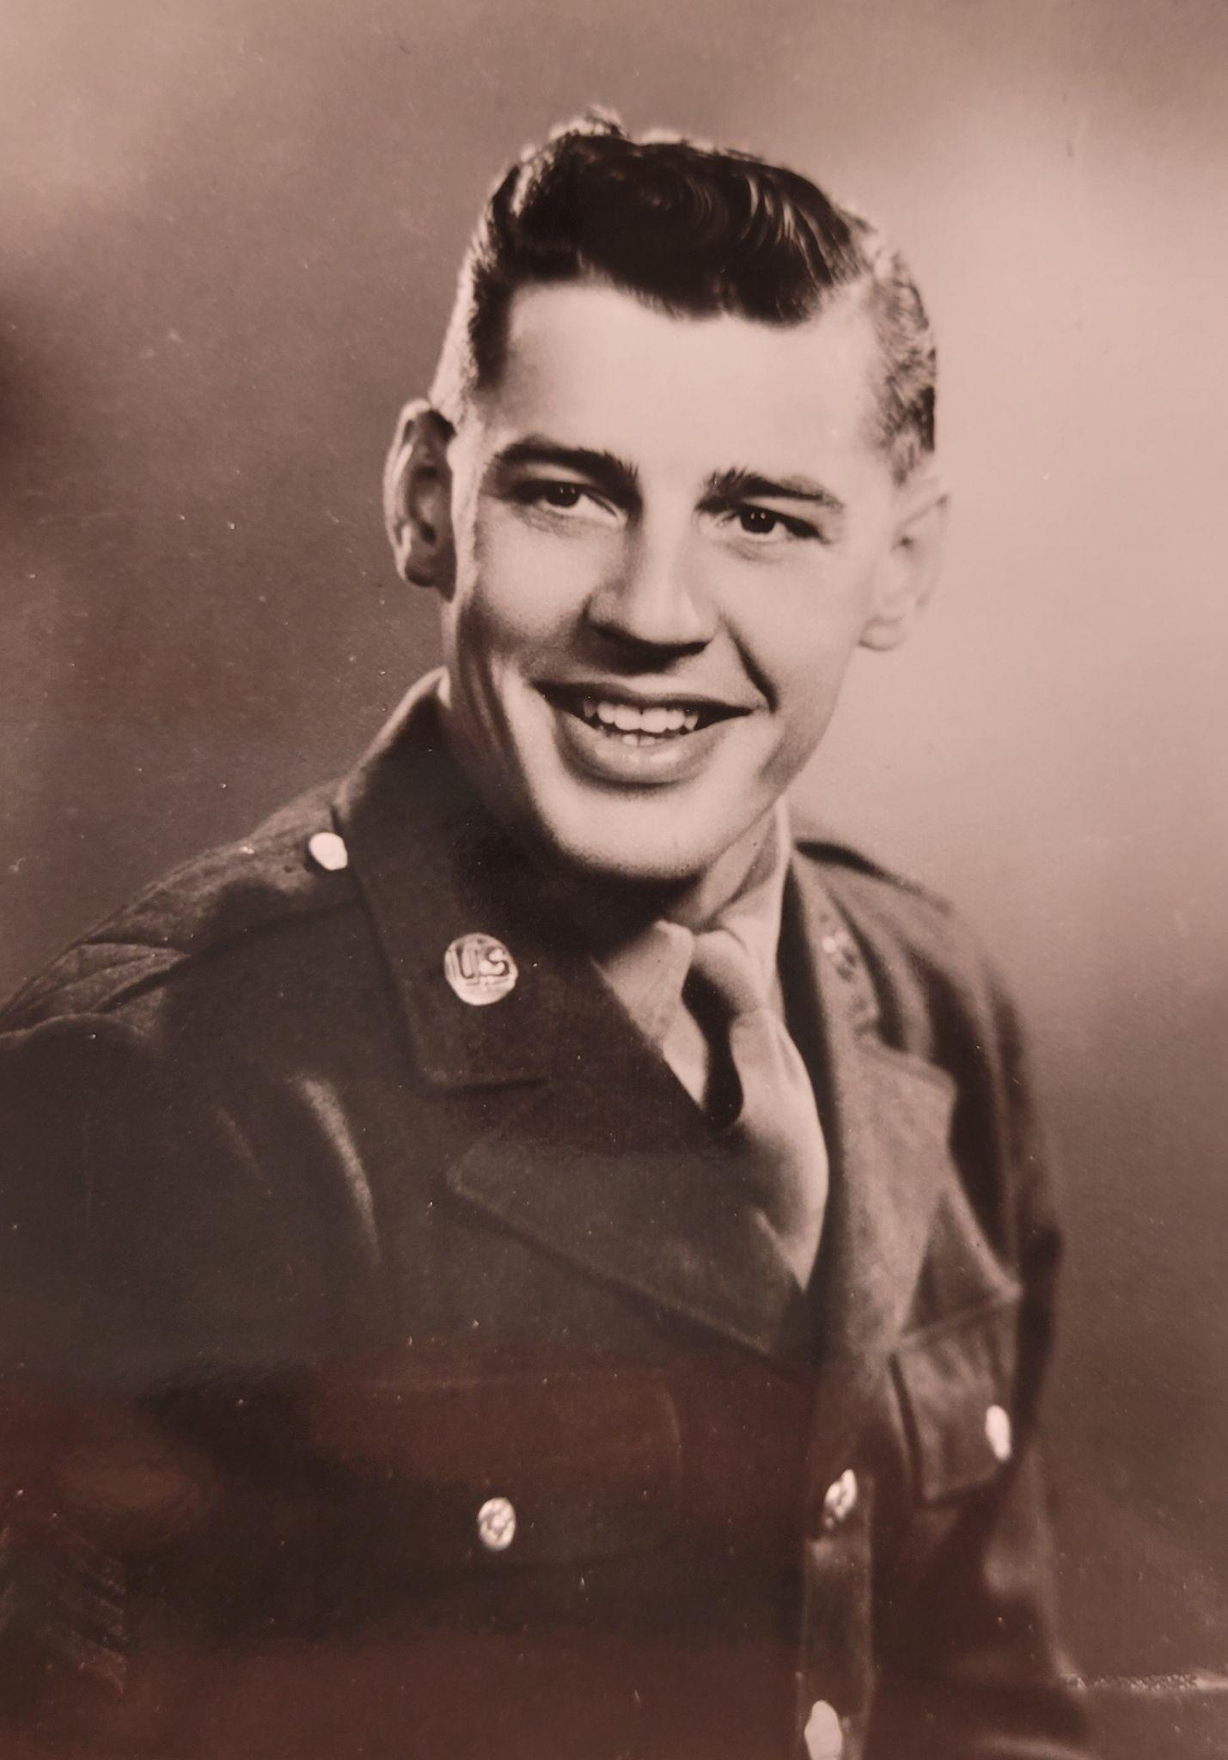
Early Life
Howard was born in 1920, in Fargo, North Dakota. His father was Howard Simmons Sr., and his mother was Edna Simmons. He graduated from Puyallup High School and worked as a gardener before attending WSC. On January 31st, 1943, he married Gwendolyn “Elsie” Weiser at the First Presbyterian Church of Puyallup. Their wedding colors were gold, blue, and rose, and the church was decorated with palm leaves and orchids. Elsie was also a student at WSC, and after their wedding, the couple returned to Pullman to finish Howard’s final year.
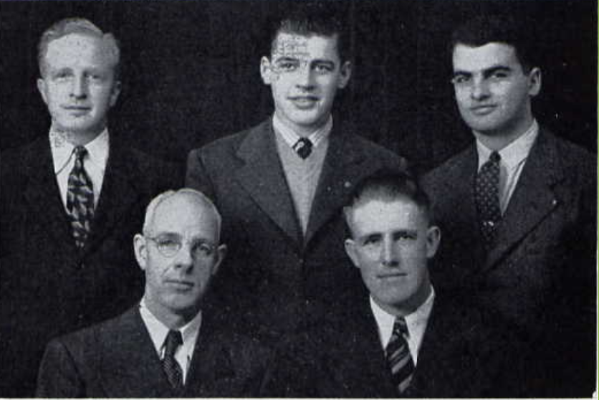
WSC Experience
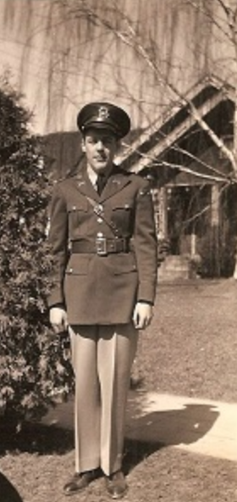
Howard attended Washington State College from 1939-1943. He graduated with a Bachelor’s in Science in Agriculture, specializing in Dairy Manufacturing. He was an active member of the Dairy Club in 1941 and 1942, and served as a judge for Dairy Production in 1942. Howard was also a member of the Phi Sigma Kappa fraternity. President Holland knew him as a student at WSC referred to him as “a young man of superior ability, industry, and promise.”
Military Service
Howard enlisted in April of 1943, just one month before his graduation at WSC. He was a Sergeant in the 114th Infantry as well as the 44th Division. He was killed in action on November 23, 1944, in Strasbourg, France.
Postwar Legacy
Howard left behind his widow Elsie, as well as his parents and two brothers. He was awarded a Purple Heart for his service. He is buried in the Epinal American Cemetery and Memorial, in Dinozé, France.

U.S Census Bureau, Sixteenth Census of the United States: 1940, Population Schedule, https://www.ancestry.com/discoveryui-content/view/65124307:2442 (accessed June 2022).
Hosmer, Page. “Simmons-Weiser Nuptials Held in Puyallup,” The News Tribune, February 2, 1943, https://www.newspapers.com/image/733579379/?article=2e50651f-0e31-4279-8c5f-1b349291d90e&focus=0.2568606,0.17793038,0.37858686,0.65138763&xid=3398 (accessed June 2022).
Washington State College, The Chinook, (Pullman, Washington: 1942), 333, Ancestry, https://www.ancestry.com/discoveryui-content/view/1443392109:1265?_phsrc=CLX30&_phstart=successSource&gsfn=howard&gsln=simmons&ml_rpos=4&queryId=ff54ef75729e8c517ec334fe33f01238, accessed June 2022.
Hosmer.
Holland to Mr. and Mrs. Howard E. Simmons, Jr., April 5, 1945, War Records 10b, 31, Washington State University Manuscripts, Archives, & Special Collections.
United States of America, United States Army, Registration Card, Order Number T 10-931-17, https://www.ancestry.com/discoveryui-content/view/37080237:2238 (accessed June 2022).
Simmons, Howard E. Fields of Honor Database, https://www.fieldsofhonor-database.com/index.php/en/american-war-cemetery-epinal-s/71397-simmons-howard-e-epi-b-24-27 (accessed June 2022).
In Memory of Howard E. Simmons, https://www.abmc.gov/print/certificate/371009 (accessed July 2022).

