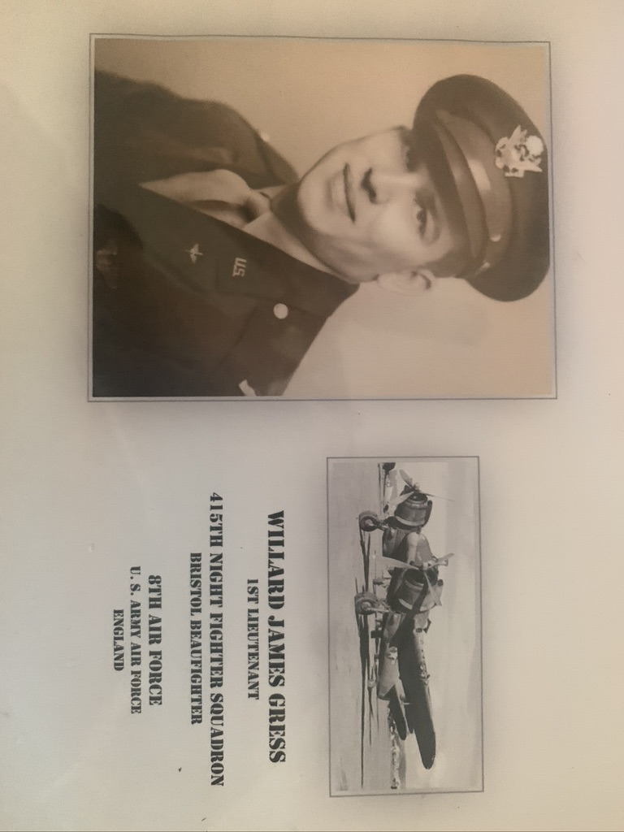
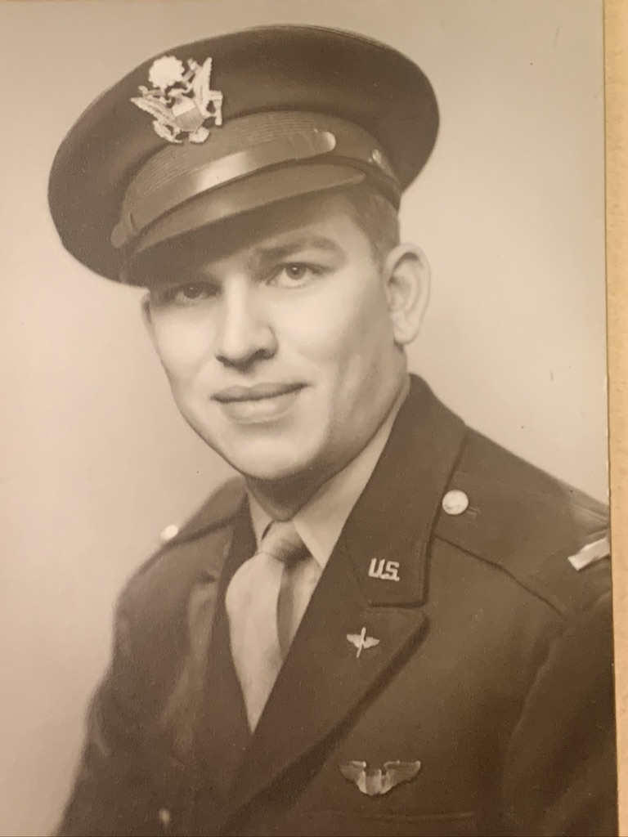
Willard Gress in his military uniform around 1941
Courtesy of his son, Jim Gress
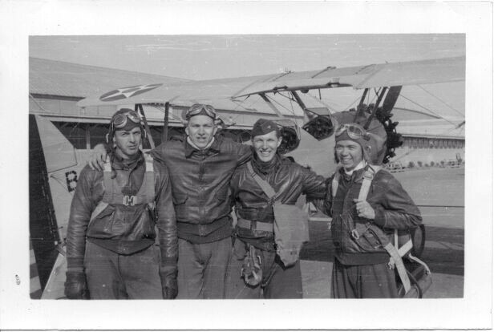
Willard Gress with other pilots in Miami
Courtesy of his grandson, Jacob Gress

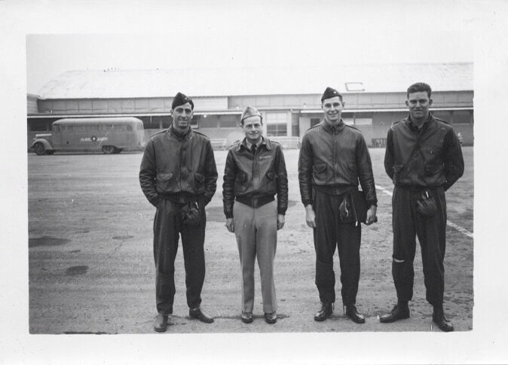

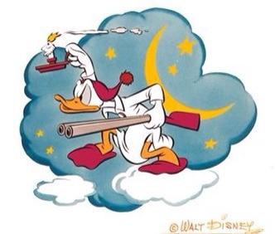
415th Night Fighter Squadron Patch Artwork designed by Walt Disney
Courtesy of his grandson, Jacob Gress

