Early Life
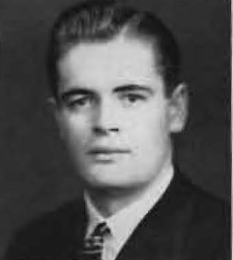
Gerald Eugene Mohr was born on May 20th, 1922, in Colfax, Washington. His father Eugene was a grain farmer who was born in Nebraska, and his mother Lydia was born in Poland. As a child, his parents ran a boarding house. In 1943, Mohr married Ruth Marian Erickson, on Christmas Eve of his senior year at WSC. Ruth was also a senior at WSC when the pair married, and was the daughter of a WSC psychology professor, Dr. Carl Erickson.
WSC Experience
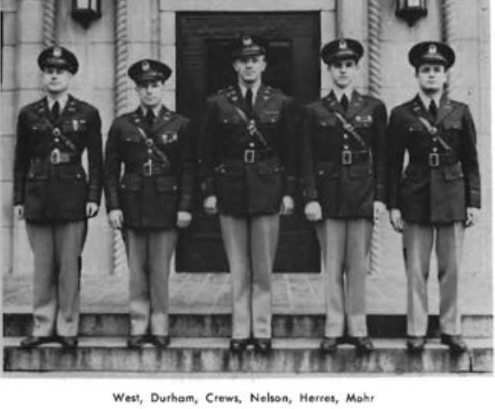
Mohr attended Washington State College from 1939-1943, earning a Bachelor of Arts in Music, with honors. Mohr was very active with campus life, living in Stimson Hall during his freshman year. He also joined the fraternity Alpha Kappa Lambda that year. Mohr often took on leadership roles on campus, and was even nominated for student council elections. Music was a big part of Mohr’s life at WSC. In addition to AKL, Mohr was initiated into Phi Mu Alpha, a national men’s music honors society. Mohr shared his love of music with his hometown by bringing a quartet of musicians from campus to Colfax High School to perform for an assembly. Another way that Mohr was able to share his musical talent and leadership abilities was through ROTC. From 1941 to 1943, Mohr worked for WSC as the Band Leader and Drum Major of the ROTC Band. Through the help of the Military Department, eighty-two people played music for pep rallies under Mohr’s leadership. He also ran an all-men’s chorus of 50 voices.
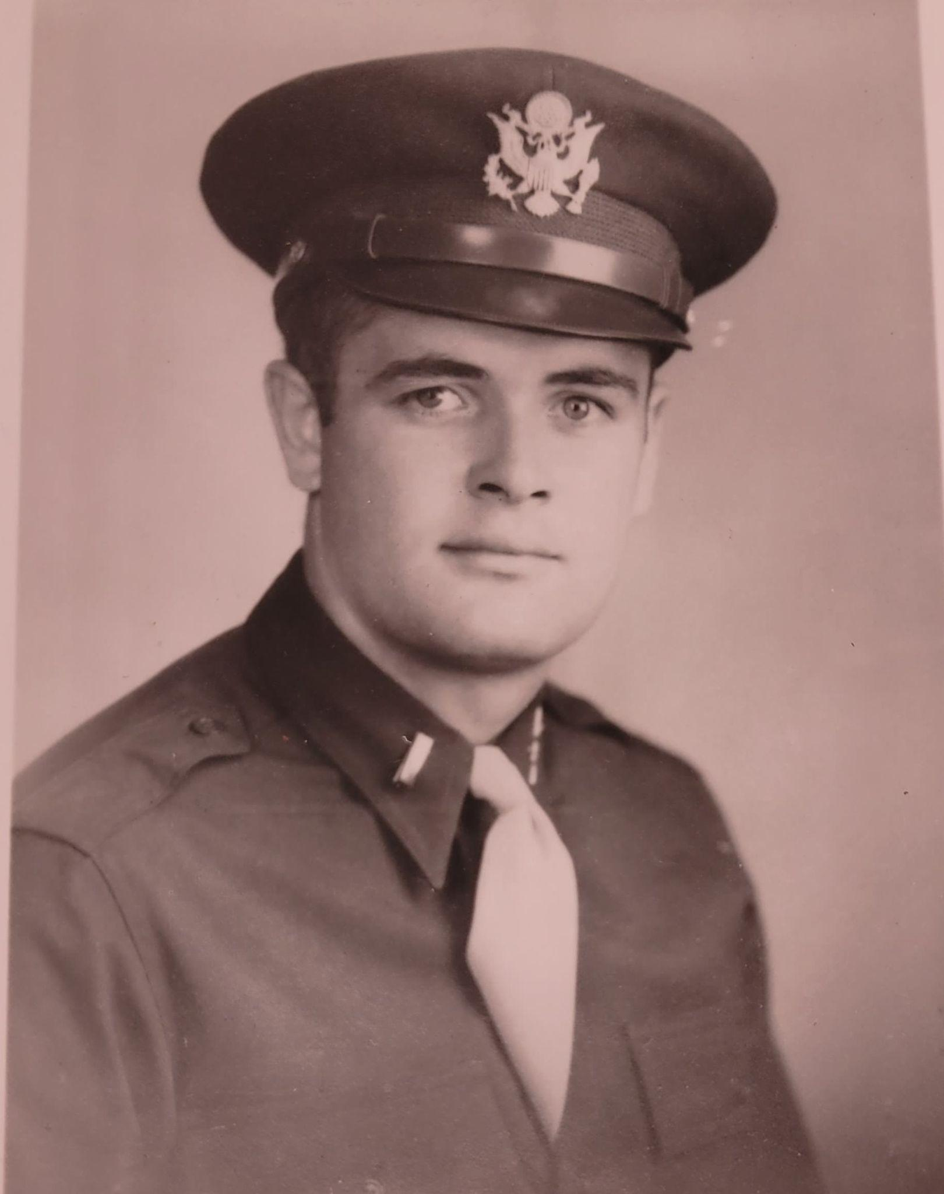
Military Service
In May of 1943, Mohr and the rest of the ROTC Band enlisted in the military. Mohr received his commission at Fort Benning, Georgia, where he started a men’s chorus. He was moved to Camp Wheeler in Macon, Georgia, where he served as a motor school instructor, director of the bugle school, and as a special services officer. He suffered a heart attack on July 4th, 1943. He had earned the rank of Second Lieutenant General.
Burial, Recognition, and Legacy
Mohr was remembered for his musical talent. He is buried in the Colfax Cemetery in Whitman County.

Registration Card, Gerald Eugene Mohr, DSS Form 1, National Archives and Record Administration, https://www.ancestry.com/discoveryui-content/view/37156667:2238?tid=&pid=&queryId=761c0898a23dfb1fdb447c29379722c7&_phsrc=CLX81&_phstart=successSource (accessed July 2022).
U.S Census Bureau, Fifteenth Census of the United States: 1930, Population Schedule, https://www.ancestry.com/discoveryui-content/view/112948172:6224 (accessed July 2022).
STATE OF WASHINGTON, County of Whitman, Marriage Certificate, Gerald E. Mohr and Ruth M. Erickson, December 24, 1943, https://www.ancestry.com/discoveryui-content/view/2022032:2378?tid=&pid=&queryId=761c0898a23dfb1fdb447c29379722c7&_phsrc=CLX81&_phstart=successSource (accessed July 2022).
“Obituaries,” Powwow, October 1944, 17.
Washington State University, Board of Regents Minutes, 1943-05-23, WSU Libraries Digital Collections, 118.
Washington State College, The Chinook, (Pullman, Washington: 1940), 264.
Washington State College, The Chinook, (Pullman, Washington: 1940), 243.
“EVERGREEN SAMPLE BALLOT,” Evergreen, March 2, 1943, WSU Libraries Digital Collections.
“Local Phi Mu Has Initiation,” Evergreen, November 20 1940, WSU Libraries Digital Collections.
“Students Entertain Colfax Assembly,” Evergreen, January 20, 1941, WSU Libraries Digital Collections.
Washington State University, Board of Regents Minutes, 1942-12-11, WSU Libraries Digital Collections, 20.
“ROTC Band Makes Debut at Rally,” Evergreen, October 6, 1942, WSU Libraries Digital Collections.
“New Cougar Chorus,” Evergreen, January 30, 1942, WSU Libraries Digital Collections.
“Obituaries,” Powwow, October 1944, 17.
“Lieut Gerald E. Mohr,” Find a Grave, https://www.ancestry.com/discoveryui-content/view/42410476:60525 (accessed July 2022).

