Pre-WSC Life
Frank Andrew Waldner was born on January 7th, 1919, in Saint Paul, Minnesota to Frank “Franz” and Margaret Waldner. He was a first generation American, as both his parents were born in Austria-Hungary. Waldner had one sister, Marie, and one brother, Arthur. Shortly after his birth in Minnesota, Waldner’s family relocated to Tacoma, Washington. Approximately 300 miles from Pullman, Washington, Tacoma was founded in 1872. It was initially named “Commencement City” and became a bustling town following the Northern Pacific Railroad’s arrival to the area. When the Waldners arrived shortly after the First World War, Tacoma would have still been experiencing an industrial boom, making it an attractive town for opportunities.
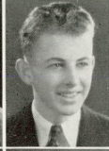
Waldner attended and graduated from Lincoln High School (located in Tacoma). In 1939, he left Tacoma to pursue a higher education at Washington State College.

“U.S., School Yearbooks, 1900-1999,” Ancestry.
WSC Experience
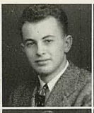
Waldner attended Washington State College from 1939 to 1943. He majored in Forestry and was quite active in extracurricular activities during his time at WSC. He was president of the Forestry Club as well as a member of Alpha Zeta, Scabbard and Blade honorary society, and the Western Forestry Club Conclave. Waldner was seemingly a committed and ambitious student. Furthermore, WSC student newspaper Evergreen reported Waldner as having “outstanding scholarship, character and leadership in the agricultural field.” These attributes followed him into his military service as well. In 1943, Waldner successfully graduated from WSC with his B.S.

“U.S., School Yearbooks, 1900-1999,” Ancestry.

Military Service
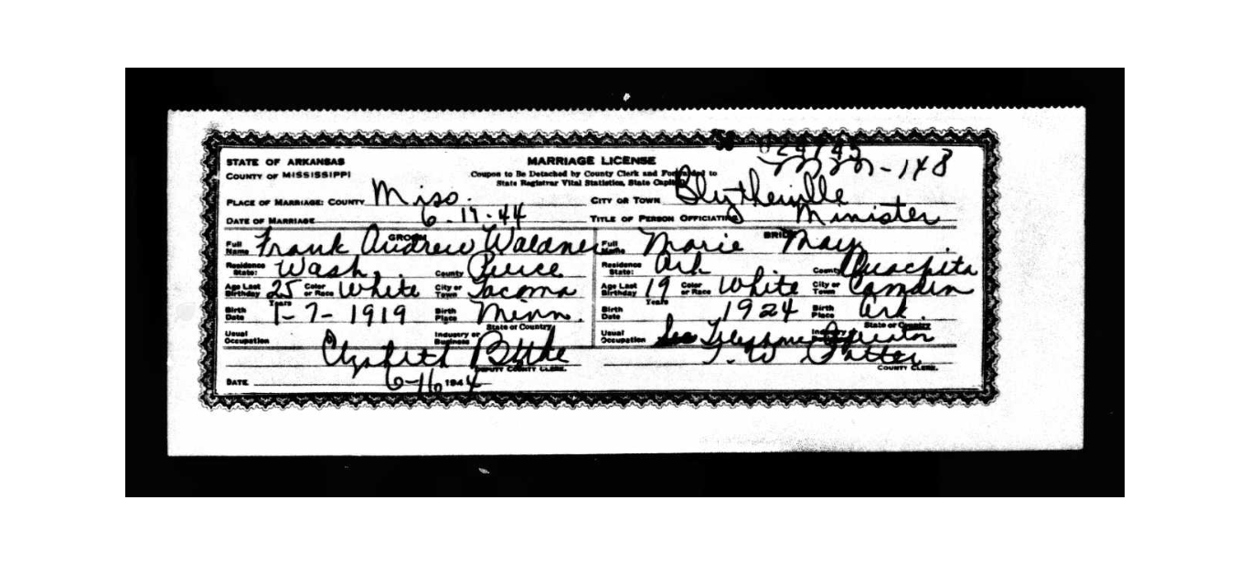
Waldner enlisted for the draft on October 25 of 1940 while still in Pullman attending Washington State College. After graduating from WSC, Waldner was assigned to relocate to Camden, Arkansas for pilot training by the Air Corps in 1944. Apparently, this was something Waldner had looked forward to for some time, as WSC’s Powwow reported he had “finally achieved his aim of being accepted by the Air Corps.” While in Camden, he met and married Marie J. May on June 17th, 1944.

“Arkansas, Marriage Certificates, 1917-1969,” Ancestry.
Waldner received further military training at Fort Benning in Georgia and Camp van Dorn in Mississippi. He went on to serve as a 2nd lieutenant with the 63rd Infantry Division, 255th Infantry Regiment, Headquarters Company, 2nd Infantry Battalion. In December of 1944, Waldner was sent overseas. While in France, he was killed on January 23rd, 1945—just one month after being sent abroad. In a letter to Waldner’s wife, Marie, a Captain in Waldner’s unit by the name of Fox wrote of the circumstances surrounding Waldner’s death. Captain Fox explained that, fearing their battalion was outnumbered by German soldiers, they received orders to lay a mine field late at night. Being the Platoon leader, Waldner was assigned this job. Captain Fox wrote, “He [Waldner] didn’t want to go that night—I believe he had a premonition of what would come.” Nevertheless, in snow that was over a foot deep, Waldner—leading six other men—set out to establish the mine field. However, in the bright white snow, German soldiers quickly spotted Waldner, causing him to be in direct line of fire. Captain Fox assured Marie that her husband had not suffered, as he was instantly killed by a German machine gun.
Captain Fox asserted the following regarding Waldner’s death: “…he saved the lives of the six men with him—by being out ahead of them…. Frank always did things that way—if the job was dangerous he always went along with ‘his boys,’ always went ahead of them. Everyone thought the world of Frank. No one in the Bn. [battalion] was better liked than he. His men worshipped him.” Waldner died a hero.

Burial, Recognition, and Legacy
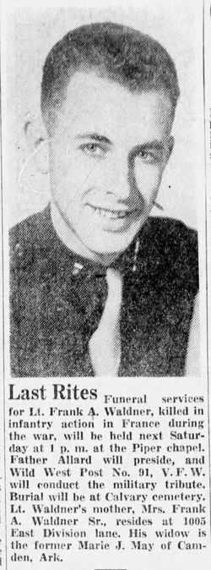
Following his death, Waldner was laid to rest in Calvary Cemetery in Tacoma, Washington. In a letter to Dr. Holland, Waldner’s mother, Margaret, wrote the following regarding her son: “Words cannot convey the feeling of those bereaved. Frank’s passing has left a wound that will never heal. He, like so many wonderful young men, and young women too, has made the supreme sacrifice. It is indeed the world’s loss.” He is memorialized on the WSU Veterans Memorial.

Ancestry

Bibliography
“Arkansas, Marriage Certificates, 1917-1969.” Ancestry. https://www.ancestry.com/discoveryui-content/view/841601:61775?tid=&pid=&queryId=d98cf37d007d8877f6d3581e82e2224d&_phsrc=BkX250&_phstart=successSource.
“Evergreen, 1940-12-02.” WSU Libraries Digital Collections. https://content.libraries.wsu.edu/digital/collection/evergreens/id/15083/rec/7.
“Evergreen, 1945-03-21.” WSU Libraries Digital Collections. https://content.libraries.wsu.edu/digital/collection/evergreens/id/16694/rec/9.
“Letter from Captain Fox to Marie Waldner.” Washington State University Manuscripts, Archives and Special Collections (MASC). War Records. Folder #13.
“Powwow, 1944, May.” WSU Libraries Digital Collections. https://content.libraries.wsu.edu/digital/collection/powwows/id/9308/rec/6.
Pierce County. “History.” 16 July 2022. https://www.piercecountywa.gov/197/History#:~:text=Tacoma%20was%20founded%20in%201872,blacksmith%20and%20approximately%20100%20citizens.
“U.S., School Yearbooks, 1900-1999.” Ancestry. https://www.ancestry.com/discoveryui-content/view/1416468359:1265?tid=&pid=&queryId=624b124a6bb04b997ba50aef0c72c3d5&_phsrc=BkX249&_phstart=successSource.
“U.S., School Yearbooks, 1900-1999.” Ancestry. https://www.ancestry.com/imageviewer/collections/1265/images/1265_b890646-00068?treeid=&personid=&rc=&usePUB=true&_phsrc=BkX23&_phstart=successSource&pId=1436780695.
“1930 United States Federal Census.” Ancestry. https://www.ancestry.com/discoveryui-content/view/112470019:6224.

“1930 United States Federal Census,” Ancestry (https://www.ancestry.com/discoveryui-content/view/112470019:6224).
Pierce County, “History,” 16 July 2022, https://www.piercecountywa.gov/197/History#:~:text=Tacoma%20was%20founded%20in%201872,blacksmith%20and%20approximately%20100%20citizens.
“U.S., School Yearbooks, 1900-1999,” Ancestry (https://www.ancestry.com/discoveryui-content/view/1416468359:1265?tid=&pid=&queryId=624b124a6bb04b997ba50aef0c72c3d5&_phsrc=BkX249&_phstart=successSource).
“U.S., School Yearbooks, 1900-1999,” Ancestry (https://www.ancestry.com/imageviewer/collections/1265/images/1265_b890646-00068?treeid=&personid=&rc=&usePUB=true&_phsrc=BkX23&_phstart=successSource&pId=1436780695).
“Evergreen, 1940-12-02,” WSU Libraries Digital Collections (https://content.libraries.wsu.edu/digital/collection/evergreens/id/15083/rec/7).
“Powwow, 1944, May,” WSU Libraries Digital Collections (https://content.libraries.wsu.edu/digital/collection/powwows/id/9308/rec/6).
“Arkansas, Marriage Certificates, 1917-1969,” Ancestry (https://www.ancestry.com/discoveryui-content/view/841601:61775?tid=&pid=&queryId=d98cf37d007d8877f6d3581e82e2224d&_phsrc=BkX250&_phstart=successSource).
“Evergreen, 1945-03-21,” WSU Libraries Digital Collections (https://content.libraries.wsu.edu/digital/collection/evergreens/id/16694/rec/9).
“Letter from Captain Fox to Marie Waldner,” Washington State University Manuscripts, Archives and Special Collections (MASC), War Records, Folder #13.
Ibid.
Ibid.
Ibid.

