Wilbur “Bill” Earl Sommers
Early Life
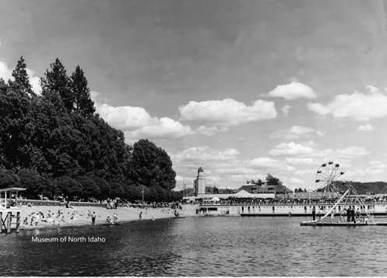
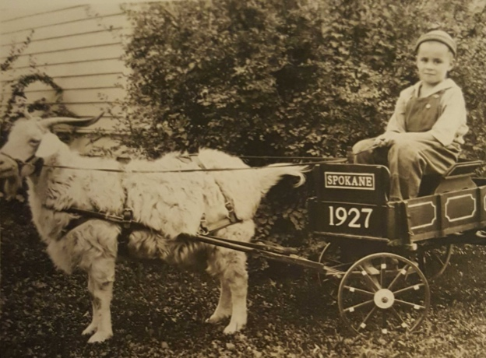
Wilbur Earl Sommers was born on August 23, 1918, in Spokane, Washington. His parents Wilbur Earl Sommers Sr. and Byrd had him baptized at St. Matthew’s Episcopal Mission in 1923. Wilbur had one sibling, an older brother John who was 8 years his senior and who had moved out of the familial home by Wilbur’s eleventh birthday. By age ten, Wilbur began going by “Bill,” while his father started going by “W. Earl” to differentiate themselves. During Bill’s childhood, Earl worked in entertainment, serving first as a businessman in a candy company and eventually opening the travelling carnival, W.E. Somers Amusement Co. In 1942, while Wilbur attended university at Washington State College, Earl and Byrd opened the Playland Pier Amusement Park in Coeur D’Alene, Idaho and in 1945 Earl was elected as president of the Coeur D’Alene Chamber of Commerce. In 1946, Earl transitioned from this role to focusing on his position as chairman of the City and Lake Front Improvement Commission. The Playland Pier was a popular place for children and families in Coeur D’Alene until 1974, when it closed its doors shortly before Earl’s retirement.
WSC Experience
Bill began attending Washington State College in 1938. While there he was an extremely active member of the WSC campus. Bill was a member of Theta Chi, a fraternity for business majors. He was also a member of the Advertising Club and Alpha Delta Sigma, a fraternity for students with aspirations towards professional advertising. As a sophomore, Bill ran for one of two “Yell Duke” positions on the ASSCW (student council) board. A member of the WSU ROTC for his first two years, Bill served in the Company “C” Infantry in a leadership position as a Second Lieutenant in the second semester of his junior year. In his senior year, Bill served as chairman for the open house committee and was responsible for managing a small group of coeds to organize university open days. Bill also served on the Chinook Business Staff as the collections manager for historical copies of the Washington State College yearbook. Socially, in his freshman year, Bill was invited to participate in the Ferry Hall Sphinx Club’s formal and travelled to Seattle to celebrate New Years with friends. Upon graduating in 1941, Bill received his commission as a Second Lieutenant in the United States Army Quartermaster Corps where he served as a pilot. He received orders away from the WSC unit in February 1942.
Military Service
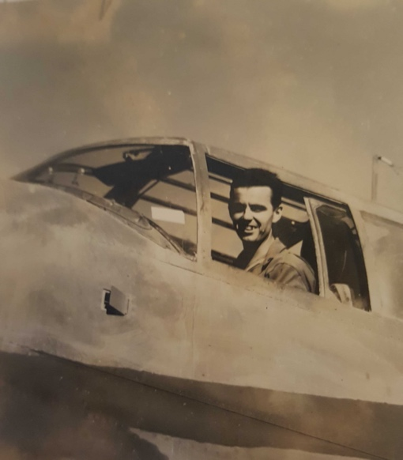
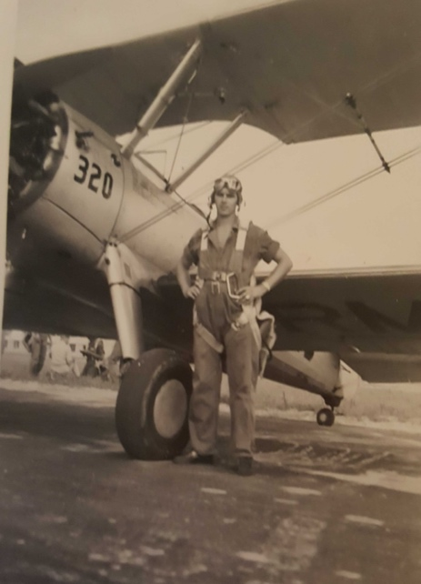
The US Army Quartermaster Corps operated as a supply force for the US Army and Navy across the European, African, and Pacific theatres during WWII. After completing his flight training with the Quartermaster Corps, Bill transferred to the US Army Air Corps to serve as a test pilot in 1942 and was stationed overseas in May of that year. During the Sicilian campaign, Bill transferred again into the Bomber Command where he served in 340th Bomb Group of the 486th Bomb Squadron as a pilot flying B-25 Mitchells. He was killed in action on February 22nd, 1944, in Pompeii, Italy, when a piece of flak hit him in the head. His co-pilot and crew took him to Pompeii Airfield where he died at the hospital. Shortly before his death, Bill had written home to his parents announcing he was coming up on leave. Bill had undertaken his final flight voluntarily, delaying his furlough to help pilot additional flights.
Burial, Recognition, and Legacy
Wilbur was buried in 1945 at the Sicily-Rome American Cemetery and Memorial. He received several awards for his service: the Air Medal, American Campaign Medal (for his service as a test-pilot), Distinguished Flying Cross, European-African-Middle Eastern Campaign Medal, the Purple Heart, and the World War II Victory Medal. In 1945, just five years after Wilbur’s death and the opening of their Coeur D’Alene amusement park together, his parents separated. Wilbur’s father, Earl, died in 1974 at the age of 80, in Coeur D’Alene, Idaho. Although Wilbur, is not mentioned by name in either of his parents’ obituaries, Byrd Sommer’s obit commends her actions as a “gold-star” mother, or a parent whose son or daughter died in service of the United States Armed forces. During Wilbur’s tenure in the Army Airforce, Byrd was also active in the Gray Ladies club of Spokane, which worked with the Red Cross at Camp Farragut providing medical services to injured soldiers. This demonstrates Byrd’s commitment to ensuring soldier’s welfare and is undoubtably a consequence of her own son’s service. Bill is listed, by his legal name Wilbur, on the Washington State University’s Veteran Memorial.

Washington State Department of Health Birth Index: Reel 5 1931, https://www.ancestry.com/discoveryui-content/view/509293:1209 (accessed June 2022)
U.S Episcopal Diocese of Spokane Church Records, 1870-1970, Baptisms, https://www.ancestry.com/discoveryui-content/view/28042:61608 (accessed June 2022)
Year: 1930; Census Place: Spokane, Spokane, Washington; Page: 10B; Enumeration District: 0025; FHL microfilm: 2342249
Ibid.
Spokane Daily Chronicle; Publication Date: 22 Jul 1974; Publication Place: Spokane, Washington, USA; URL: https://www.newspapers.com/image/578133004/?article=7d6683a7-f581-469e-87ab
“Somers Resigns,” Spokane Chronicle, January 24, 1946, https://www.newspapers.com/image/564356290/?terms=wilbur%20earl%20somers&match=1 (accessed June 2022)
Ibid.
Washington State College, The Chinook, (Pullman, Washington: 1941), 263, https://www.ancestry.com/discoveryui-content/view/1443422086:1265?_phsrc=CLX15&_phstart=successSource&gsfn=wilbur+earl&gsln=somers&ml_rpos=3&queryId=ceb92cb08286b1cede526368c3b685c3 (accessed June 2022).
Washington State College, The Chinook, (Pullman, Washington: 1941), 258. https://content.libraries.wsu.edu/digital/collection/chinook/id/26574/rec/42
https://content.libraries.wsu.edu/digital/collection/evergreens/id/14116/rec/3
Washington State College, The Chinook, (Pullman, Washington: 1940), 320, https://www.ancestry.com/discoveryui-content/view/1443424628:1265?_phsrc=CLX16&_phstart=successSource&gsfn=wilbur+earl&gsln=somers&ml_rpos=4&queryId=ceb92cb08286b1cede526368c3b685c3 (accessed June 2022)
Washington State College, The Chinook, (Pullman, Washington: 1940), 34, https://content.libraries.wsu.edu/digital/collection/chinook/id/14926/rec/2 (accessed July 2024)
Washington State College, The Chinook, (Pullman, Washington: 1940), 37, https://content.libraries.wsu.edu/digital/collection/chinook/id/14926/rec/2 (accessed July 2024)
https://content.libraries.wsu.edu/digital/collection/evergreens/id/13925/rec/5, and https://content.libraries.wsu.edu/digital/collection/evergreens/id/13910/rec/3
https://content.libraries.wsu.edu/digital/collection/evergreens/id/15894/rec/1
US Army Quartermaster Corps, History, https://quartermaster.army.mil/history/index.html (accessed July 2024).
https://www.ancestry.com/mediaui-viewer/collection/1030/tree/67470320/person/160057131711/media/da0411bc-2be6-4e82-9950-deefc020d3d9?_phsrc=Zog207&usePUBJs=true&galleryindex=6&albums=pg&showGalleryAlbums=true&tab=0&pid=160057131711&sort=-created
Wilbur Earl Somers, American Air Museum in Britain, https://www.americanairmuseum.com/person/248647 (accessed June 2022).
2nd Lt. Wilbur Earl Somers, Find a Grave, https://www.findagrave.com/memorial/56314629/wilbur-earl-somers (accessed July 2022).

